**22AIE211 Introduction to Communications and IoT**

**Lab Assignment 2**

**Modulation Techniques**

**Name : Anuvind M P Date : 24/04/2024**

**Roll no : AM.EN.U4AIE22010**

1. Generate AM wave for different modulation indices(m=1, 0.5 and 1.5). Plot all the waveforms(in a single figure).(Am=Ac=5V, fs=1000Hz, fm=20Hz)

**CODE :**

clc;

close all;

clear all;

m = [0.5 1 1.5];

Am = 5; %Amplitude of modulating signal

fm = 20; %frequency of modulating signal

Tm = 1/fm;

t = 0:0.001:1;

ym = Am*sin(2*pi*fm*t);

subplot(5,1,1);

plot(t,ym)

title('Message Signal');

%Carrier signal

Ac = Am;

fc = 100;

Tc = 1/fc;

yc = Ac*sin(2*pi*fc*t);

subplot(5,1,2);

plot(t,yc)

grid on;

title('Carrier Signal');

%AM Modulation

index = 0;

titles = {'index=0.5', 'index=1', 'index=1.5'};

for i = m

subplot(5,1,3+index);

index = index + 1;

y = Ac * (1+i*sin(2*pi*fm*t)).*sin(2*pi*fc*t);

plot(t,y)

title(titles{index});

end

**OUTPUT :**

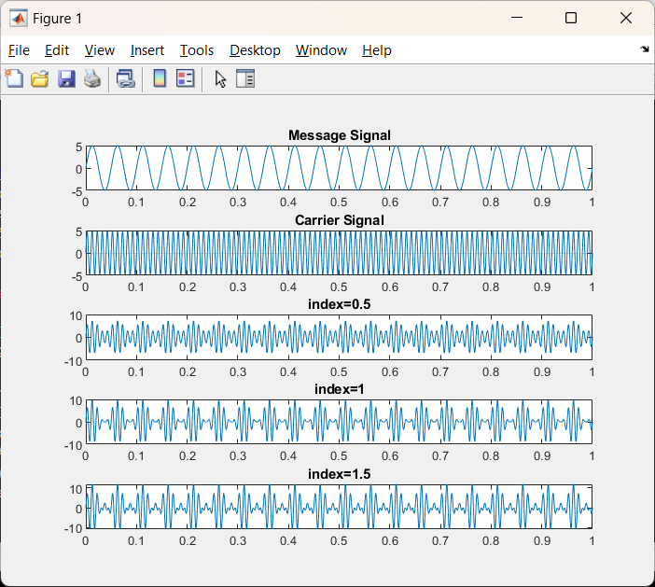

1. Generate an AM wave with message signal 2cos(πt) and carrier 4Sin(1000πt +10). (Use deg2rad() function to convert phase from degrees to radians)

**CODE :**

clc;

close all;

clear all;

t = 0:0.001:1;

ym = 2*cos(pi*t); % message signal

yc = 4*sin(100*pi*t + deg2rad(10)); % carrier signal

yam = 4*(1+cos(pi*t)).*sin(100*pi*t + deg2rad(10)); % Amplitude modulated Signal

subplot(3, 1, 1);

plot(t, ym);

title("Message Signal");

subplot(3, 1, 2);

plot(t, yc);

title("Carrier Signal");

subplot(3, 1, 3);

plot(t, yam);

title("Amplitude Modulated Signal");

**OUTPUT :**

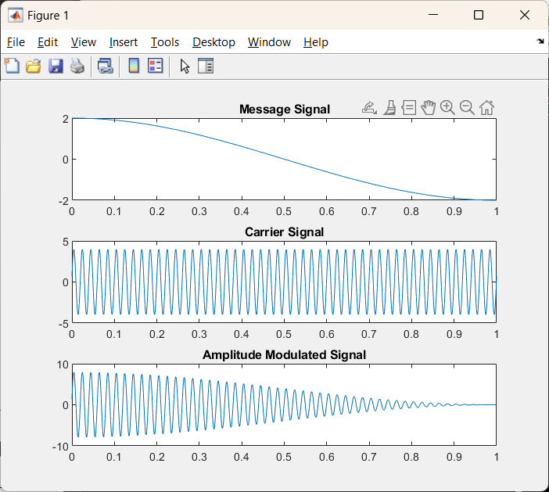

1. Generate an FM signal with mf =10. (fs=10KHz, fm=35Hz, fc=500Hz, Am=Ac=1V, time vector, t=(0:.1*fs)/fs))

**CODE :**

%parameters

fs = 10000;

fm = 35;

fc = 500;

Am = 1;

Ac = 1;

t = (0:.1*fs)/fs;

%carrier and message signals

carrier = Ac*cos(2*pi*fc*t);

message = Am*cos(2*pi*fm*t);

mf = 10;

%modulated signal

m = Ac*cos((2*pi*fc*t)+mf*sin(2*pi*fm*t));

%plot

figure;

subplot(3,1,1);

plot(t, message, 'b');

title('Message Signal');

xlabel('Time (s)');

ylabel('Amplitude');

subplot(3,1,2);

plot(t, carrier, 'r');

title('Carrier Signal');

xlabel('Time (s)');

ylabel('Amplitude');

subplot(3,1,3);

plot(t, m, 'k');

title('FM signal');

xlabel('Time (s)');

ylabel('Amplitude');

**OUTPUT :**

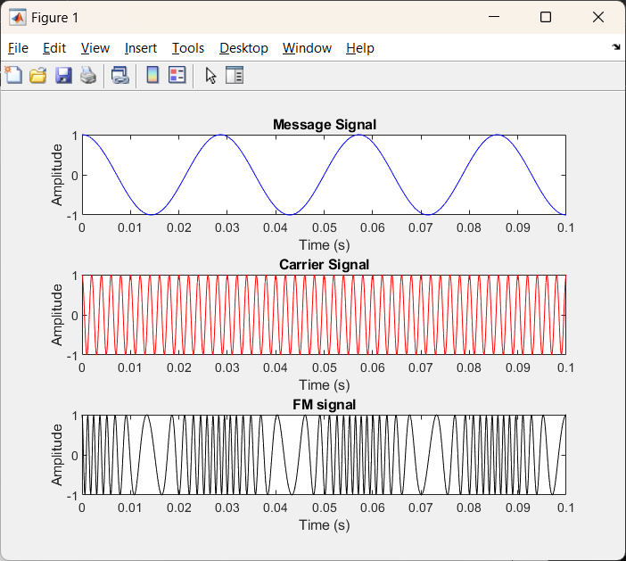

1. Generate an FM signal when message input is a sinusoidal wave and carrier is a rectangular waveform. (use in-built function, fmmod())

**CODE :**

% Parameters

Fs = 1000;

T = 1/Fs;

t = 0:T:1-T;

% Generate message signal (sinusoidal wave)

fm = 10;

Am = 1;

msg_signal = Am * sin(2*pi*fm*t);

% Generate carrier signal (rectangular waveform)

fc = 100;

Ac = 1;

carrier_signal = square(2*pi*fc*t);

% Generate FM signal using fmmod()

kf = 5;

fm_signal = fmmod(msg_signal, fc, Fs, kf);

% Plot

subplot(3,1,1);

plot(t, msg_signal);

title('Message Signal');

xlabel('Time (s)');

ylabel('Amplitude');

subplot(3,1,2);

plot(t, carrier_signal);

title('Carrier Signal (Rectangular)');

xlabel('Time (s)');

ylabel('Amplitude');

subplot(3,1,3);

plot(t, fm_signal);

title('FM Modulated Signal');

xlabel('Time (s)');

ylabel('Amplitude');

**OUTPUT :**

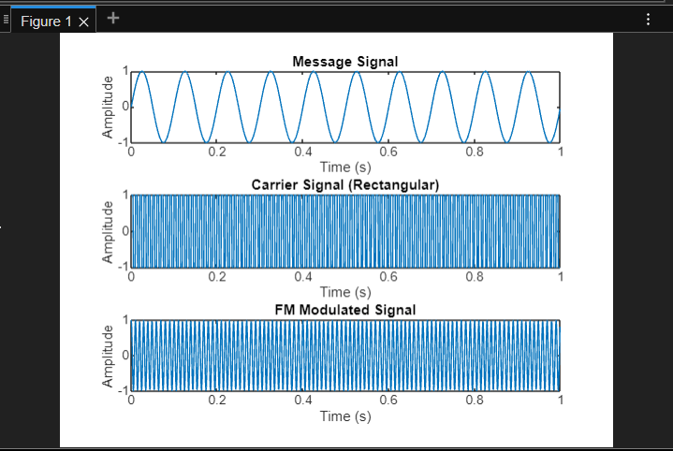

1. Generate a PM signal for modulation index, mp = 4. (Am=Ac = 5V, fm = 10Hz, fc=50Hz, timevector,t = 0:0.001:1).

**CODE :**

%parameters

Am = 5;

Ac = 5;

fm = 10;

fc = 50;

t = 0:0.001:1;

mp = 4;

%carrier and message signals

message = Am*cos(2*pi*fm*t);

carrier = Ac*cos(2*pi*fc*t + 1);

%modulated signal

m = Ac*cos((2*pi*fc*t)+mp*cos(2*pi*fm*t));

%plot

figure;

subplot(3,1,1);

plot(t, message, 'b');

title('Message Signal');

xlabel('Time (s)');

ylabel('Amplitude');

subplot(3,1,2);

plot(t, carrier, 'r');

title('Carrier Signal');

xlabel('Time (s)');

ylabel('Amplitude');

subplot(3,1,3);

plot(t, m, 'k');

title('PM signal');

xlabel('Time (s)');

ylabel('Amplitude');

**OUTPUT :**

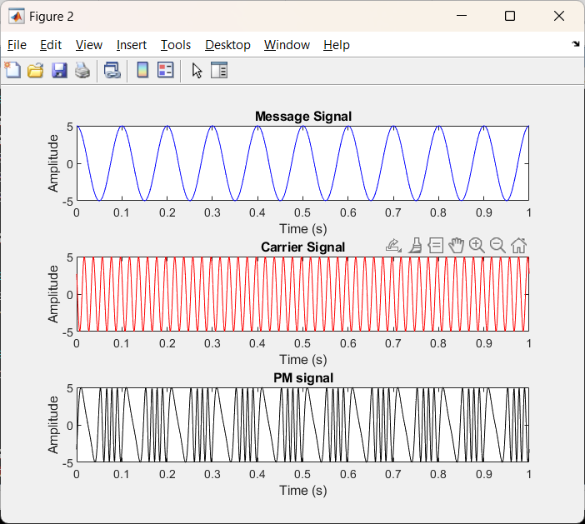

1. Generate the following signals using in-built functions in MATLAB. Perform both modulation and demodulation. a. AM signal (over modulation) b. FM signal c. PM signal

**CODE :**

clc;

close all;

clear all;

cf = 1;

Fs = 100;

mi_am = 5;

mi_fm = 5;

mi_pm = 2;

t = 0:1/Fs:5;

ym = sin(2*pi*1*t);

yc = sin(2*pi*cf*t);

yam = ammod(ym, cf, cf*mi_am);

tam = amdemod(yam, cf, cf*mi_am);

yfm = fmmod(ym, cf, cf*mi_fm, Fs);

tfm = fmdemod(yfm, cf, Fs, cf*mi_fm);

ypm = pmmod(ym, cf, cf*mi_pm, Fs);

tpm = pmdemod(ypm, cf, Fs, cf*mi_pm);

subplot(2,4,1);

plot(t, ym);

title('Message Signal');

xlabel('Time (s)');

ylabel('Amplitude');

subplot(2,4,5);

plot(t, yc);

title('Carrier Signal');

xlabel('Time (s)');

ylabel('Amplitude');

subplot(2,4,2);

plot(t, yam);

title('AM Modulated Signal');

xlabel('Time (s)');

ylabel('Amplitude');

subplot(2,4,3);

plot(t, yfm);

title('FM Modulated Signal');

xlabel('Time (s)');

ylabel('Amplitude');

subplot(2,4,4);

plot(t, ypm);

title('PM Modulated Signal');

xlabel('Time (s)');

ylabel('Amplitude');

subplot(2,4,6);

plot(t, ym);

title('AM Demodulated Signal');

xlabel('Time (s)');

ylabel('Amplitude');

subplot(2,4,7);

plot(t, ym);

title('FM Demodulated Signal');

xlabel('Time (s)');

ylabel('Amplitude');

subplot(2,4,8);

plot(t, ym);

title('PM Demodulated Signal');

xlabel('Time (s)');

ylabel('Amplitude');

**OUTPUT :**

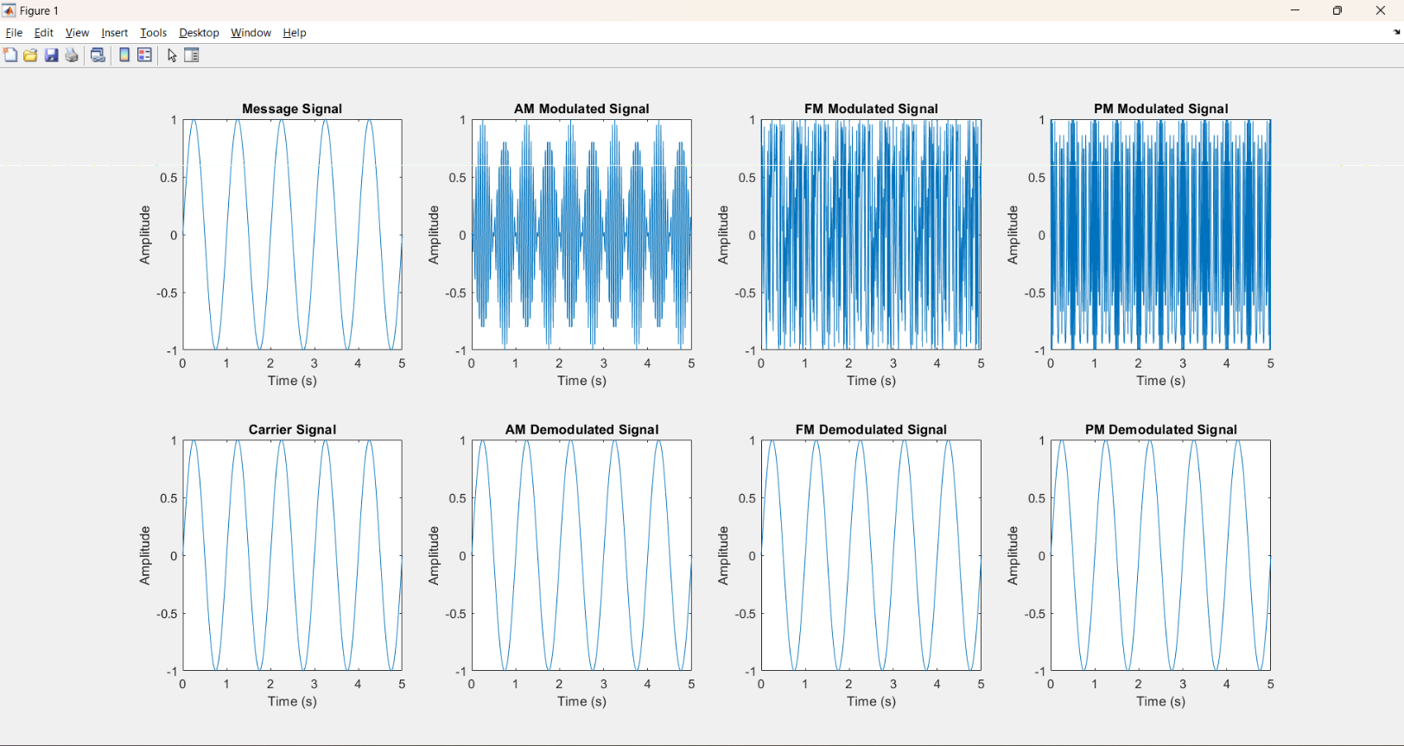

1. Generate ASK, FSK, PSK signal.

**ASK :**

x=[1 0 0 1 1 0 1];

bp=0.000001;

disp('Binary information at Transmitter :');

disp(x);

bit=[];

for n=1:1:length(x)

if x(n)==1

se=ones(1,100);

elseif x(n)==0

se=zeros(1,100);

end

bit=[bit se];

end

t1=bp/100:bp/100:100*length(x)*(bp/100);

subplot(3,1,1);

plot(t1,bit,'r');

grid on;

axis([0 bp*length(x) -.5 1.5]);

ylabel('amplitude(volt)');

xlabel('time(sec)');

title('transmitting information as digital signal');

% ASK modulation

A1=10;

A2=0;

br=1/bp;

f=br*10;

t2=bp/99:bp/99:bp;

ss=length(t2);

m=[];

for i=1:1:length(x)

if x(i)==1

y=A1*cos(2*pi*f*t2);

else

y=A2*cos(2*pi*f*t2);

end

m=[m y];

end

t3=bp/99:bp/99:bp*length(x);

subplot(3,1,2);

plot(t3,m,'b');

xlabel('time(sec)');

ylabel('amplitude(volt)');

title('ASK modulated waveform');

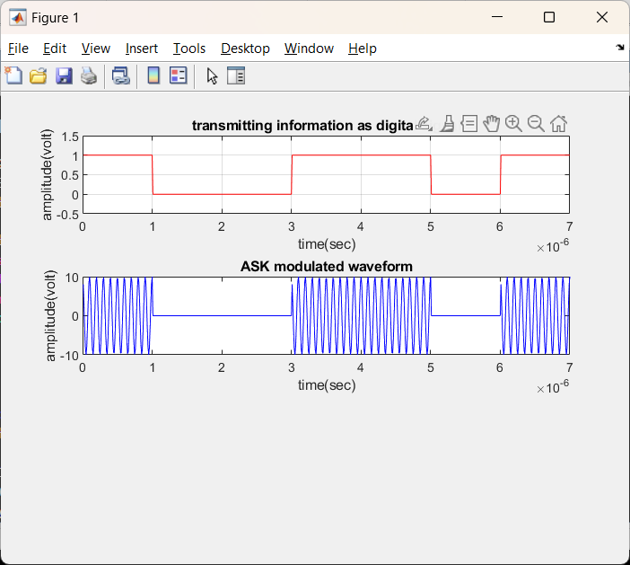

**FSK :**

x=[1 0 0 1 1 0 1];

N = length(x);

Tb = 0.0001;

disp('Binary Input Information at Transmitter: ');

disp(x);

nb = 100; % Digital signal per bit

digit = [];

for n = 1:1:N

if x(n) == 1;

sig = ones(1,nb);

else x(n) == 0;

sig = zeros(1,nb);

end

digit = [digit sig];

end

t1 = Tb/nb:Tb/nb:nb*N*(Tb/nb); % Time period

figure('Name','FSK Modulation and Demodulation','NumberTitle','off');

subplot(3,1,1);

plot(t1,digit,'LineWidth',2.5);

grid on;

axis([0 Tb*N -0.5 1.5]);

xlabel('Time(Sec)');

ylabel('Amplitude(Volts)');

title('Digital Input Signal');

Ac = 10;

br = 1/Tb;

Fc1 = br*10;

Fc2 = br*5;

t2 = Tb/nb:Tb/nb:Tb;

mod = [];

for (i = 1:1:N)

if (x(i) == 1)

y = Ac*cos(2*pi*Fc1*t2);

else

y = Ac*cos(2*pi*Fc2*t2);

end

mod = [mod y];

end

t3 = Tb/nb:Tb/nb:Tb*N; % Time period

subplot(3,1,2);

plot(t3,mod);

xlabel('Time(Sec)');

ylabel('Amplitude(Volts)');

title('FSK Modulated Signal');

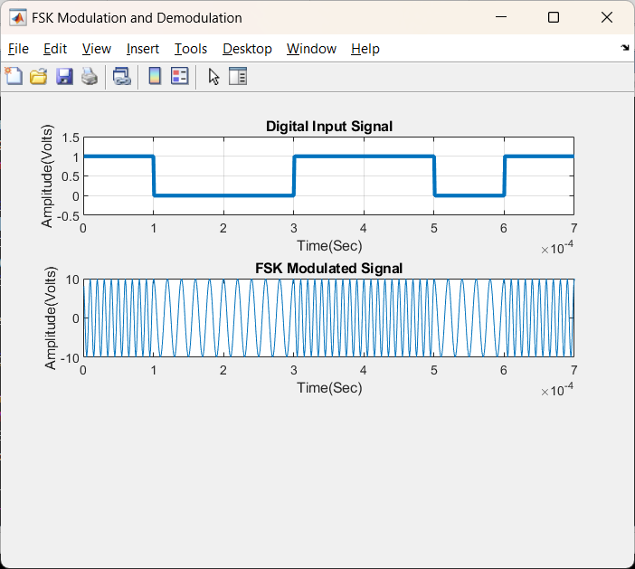

**PSK :**

x=[ 1 0 0 1 1 0 1];

bp=.000001;

disp(' Binary information at Trans mitter :');

disp(x);

bit=[];

for n=1:1:length(x)

if x(n)==1;

se=ones(1,100);

else x(n)==0;

se=zeros(1,100);

end

bit=[bit se];

end

t1=bp/100:bp/100:100*length(x)*(bp/100);

subplot(3,1,1);

plot(t1,bit,'lineWidth',2.5);grid on;

axis([ 0 bp*length(x) -.5 1.5]);

ylabel('amplitude(volt)');

xlabel(' time(sec)');

title('transmitting information as digital signal');

A=5;

br=1/bp;

f=br*2;

t2=bp/99:bp/99:bp;

ss=length(t2);

m=[];

for (i=1:1:length(x))

if (x(i)==1)

y=A*cos(2*pi*f*t2);

else

y=A*cos(2*pi*f*t2+pi);

end

m=[m y];

end

t3=bp/99:bp/99:bp*length(x);

subplot(3,1,2);

plot(t3,m);

xlabel('time(sec)');

ylabel('amplitude(volt)');

title('waveform for binary PSK modulation coresponding binary information');

